Setting up Application Environment Create IBM cloud Account

|  |  |
| --- | --- |
| Date | 11 November 2022 |
| Team ID | PNT2022TMID34253 |
| Project name | Skill and Job Recommended |
| Maximum marks | 2 marks |

Step 1 : Type or click the below link in the browser https://[www.ibm.com/academic/home](http://www.ibm.com/academic/home)

Step 2 : Click register icon and give all the details one by one,

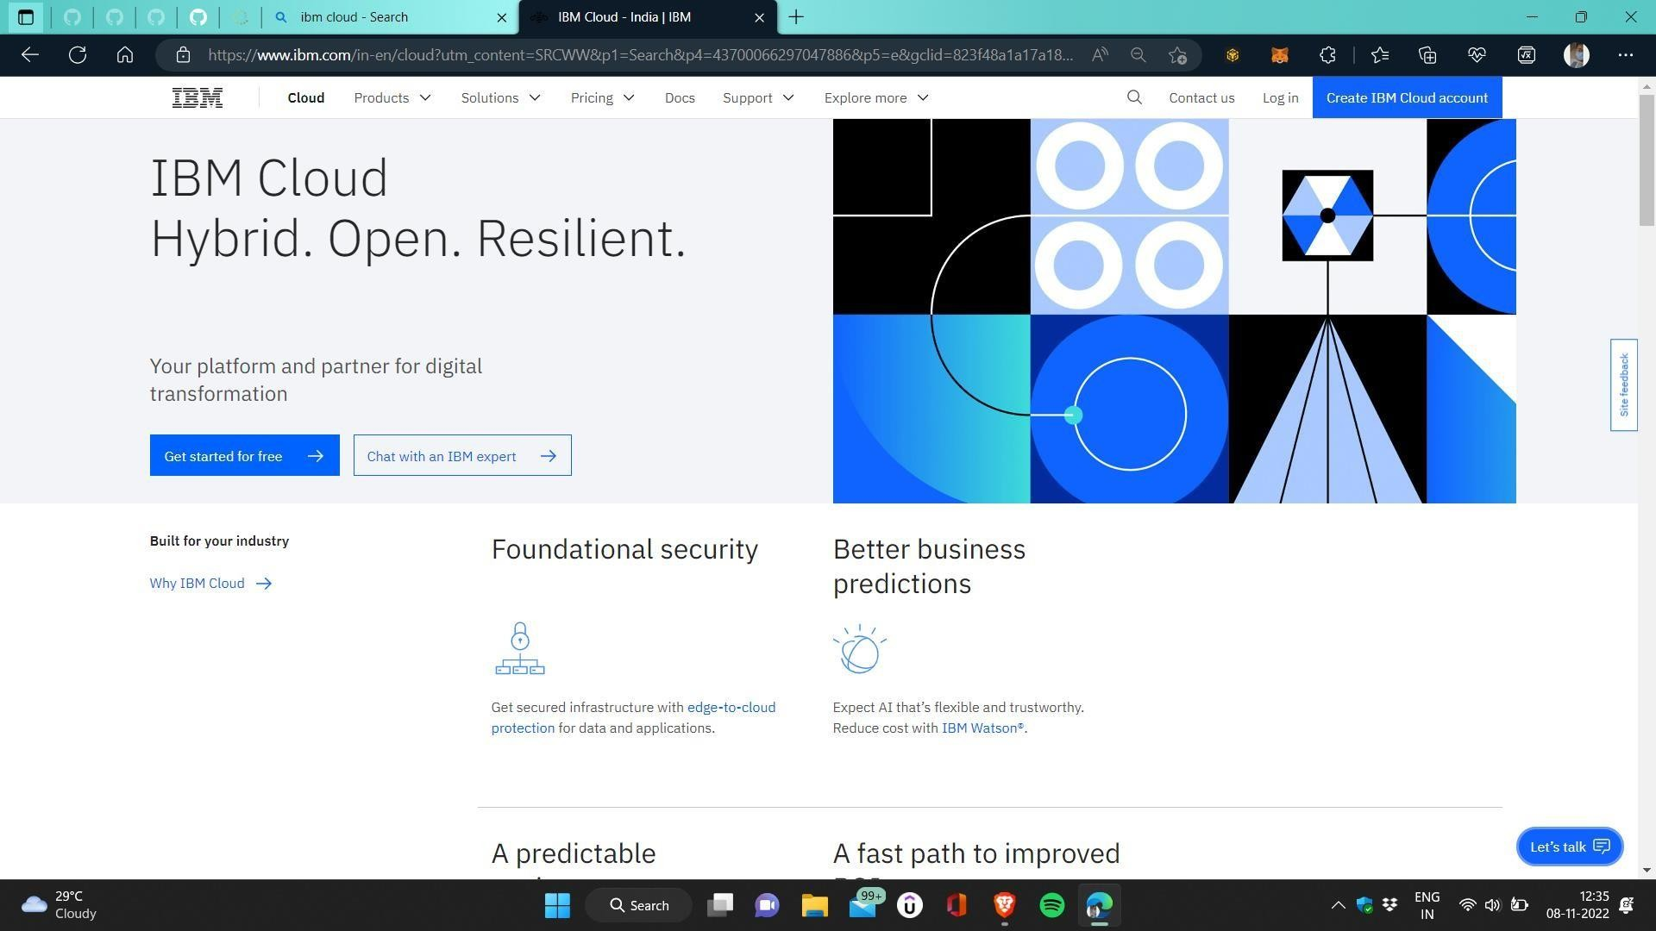

Step 3 : Already you got SI EMAIL and SI PASSWORD from your IBM student Login to your web mail account wait for 7–digit verification code in your web mail : https://sg2plmcpnl496936.prod.sin2.secureserver.net:2096/

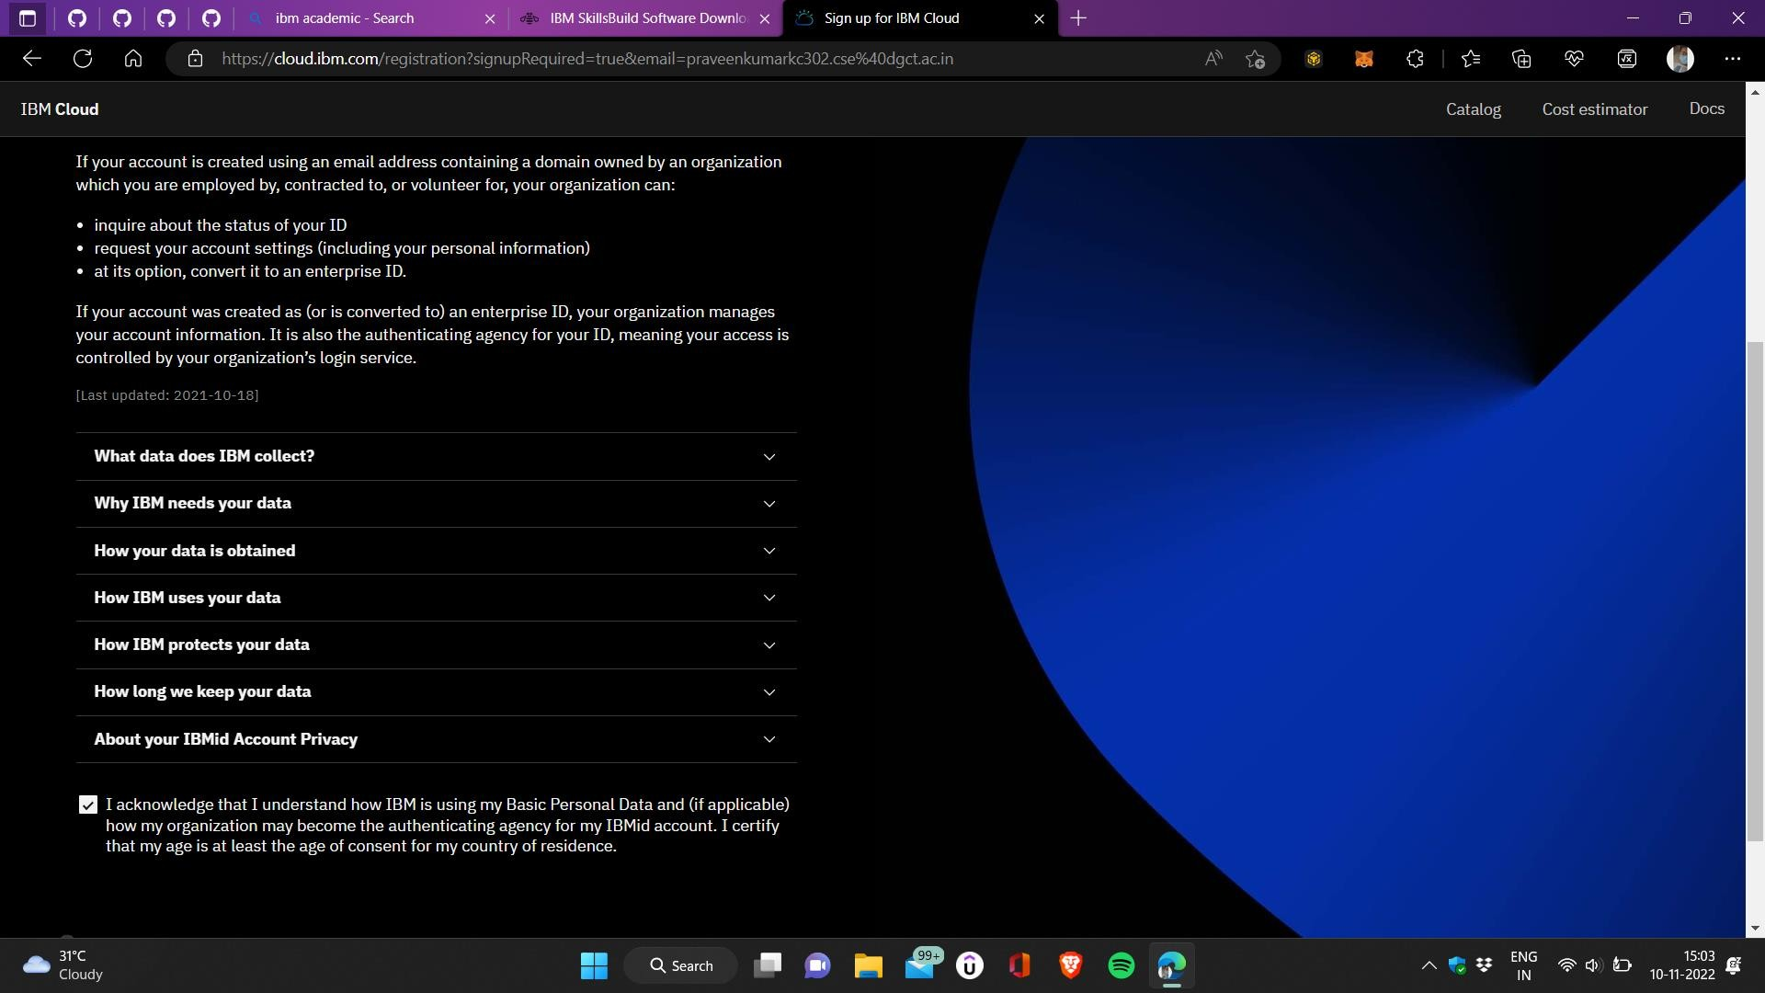

Step 4 : Get 7-digit verification code in webmail,then go to registration page and enter the verification code .

Step 5 : Now ,you have successfully created the IBM cloud Account.

Step 6 : Go to IBM Cloud login page : [https://cloud.ibm.com/login .then](https://cloud.ibm.com/login%20.then) enter your IBM Id and password.

Step 7: Finally ,you will access the IBM cloud account.

